The second Group of Calculation Options

For the second group of the calculation options we have a constant Suspension flow rate Qp and in this case the pressure difference Δp is increasing with increasing time.

We should have the same group of parameters as for the Dp=const –option. The difference is that we will have in the hc-group the additional parameter Qp and different equations. All equations which are different, compared with the option Dp=const are displayed below.

In the following you see a listing of the 4 groups:

- A, Qsus-subgroup
- Dp (please notice that the Dp is not constant for one experiment that’s why we enter the maximal reached pressure difference)
- tr, sr, sf
- tf, tc/n, Qp, hc-subgroup

Calculation of hc from A, Dp and Qp and vice versa

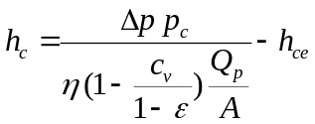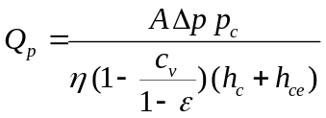

Calculation of the time tf from hc and Dp and vice versa

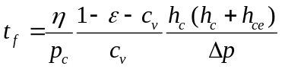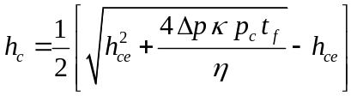

Calculation of Qp from the time tf and A and Dp and vice versa

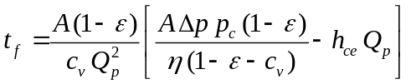

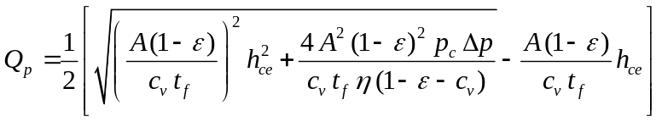

Calculation of A from Qsus

